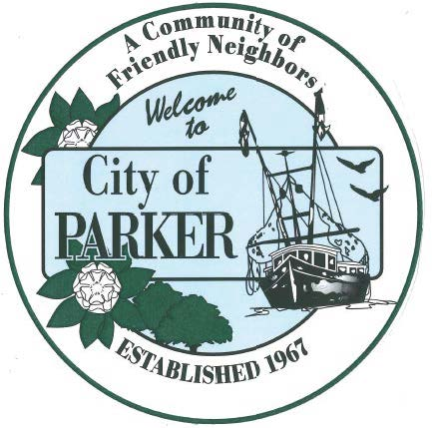 | CITY OF PARKER  AGENDA ITEM SUMMARY
1. DEPARTMENT MAKING REQUEST/NAME OF PRESENTER:  City Clerk |  | 2. MEETING DATE:  7/21/26
3. PURPOSE:
Submitting approval dates for Budget Workshop, 1st Hearing and Final Hearing
4. IS THIS ITEM BUDGETED (IF APPLICABLE)
YES NO N/A X
Budget Workshop – August 17, 2026, 10 am
First Hearing – Thursday, September 10, 2026, 5:01 pm
Final Hearing – Thursday, September 24, 2026 5:01 pm

