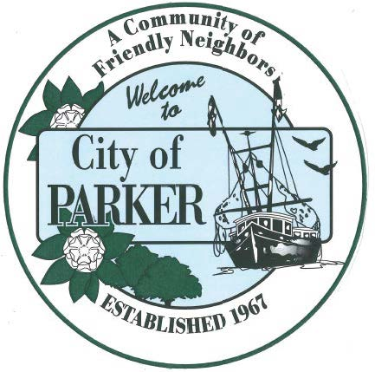 | CITY OF PARKER  AGENDA ITEM SUMMARY
1. DEPARTMENT MAKING REQUEST/NAME OF PRESENTER:  City Clerk |  | 2. MEETING DATE:  7/21/26
3. PURPOSE:
Approval of 7/7/26 minutes
4. IS THIS ITEM BUDGETED (IF APPLICABLE)
YES NO N/A X

