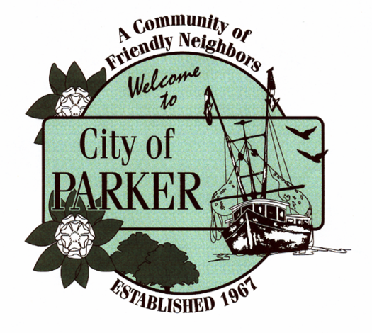

1001 W PARK STREET
CITY OF PARKER
TOWN HALL MEETING
TUESDAY
JUNE 30TH
5:00PM

