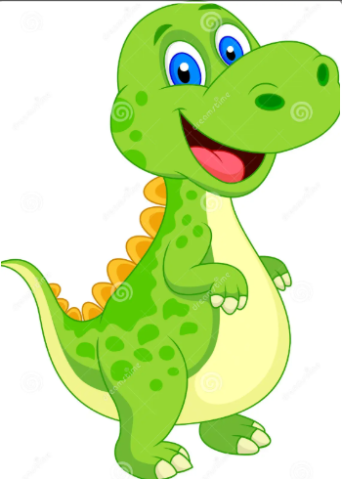
Dino Storytime Saturday, June 6th at 11:00am
Dino Arts for kids 6-12, Saturday, June 6th at 12:30 pm

