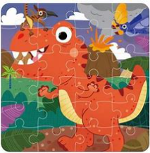
DINO PUZZLE CHALLENGE
SATURDAY, JUNE 13TH
AT 12:30 PM

