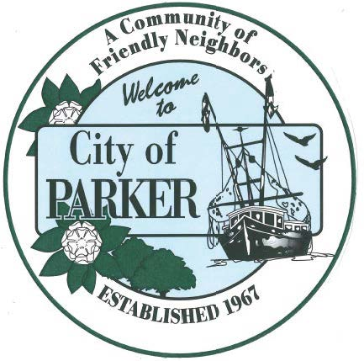 | CITY OF PARKER  AGENDA ITEM SUMMARY
1. DEPARTMENT MAKING REQUEST/NAME OF PRESENTER:  Council |  | 2. MEETING DATE:  6/8/26
3. PURPOSE:
Discussion to Approve/Disapprove Clearwave Fiber
4. IS THIS ITEM BUDGETED (IF APPLICABLE)
YES NO N/A X
Fiber Optic Internet provided to the city

