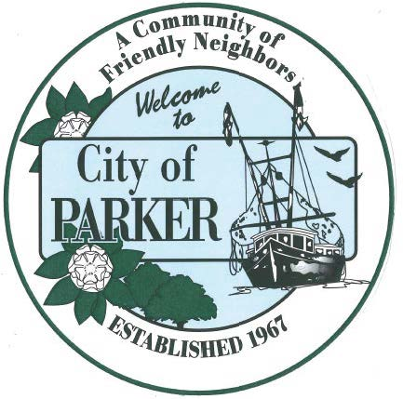 | CITY OF PARKER  AGENDA ITEM SUMMARY
1. DEPARTMENT MAKING REQUEST/NAME OF PRESENTER:  City Clerk |  | 2. MEETING DATE:  5/19/26
3. PURPOSE:
Approval of minutes for 5/5/26 meeting
4. IS THIS ITEM BUDGETED (IF APPLICABLE)
YES NO N/A X

