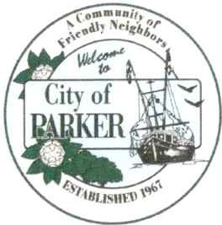
Planning Committee Mark Rega, Chairman Rich Hall

Kyle Merritt Ann Palrang Terence Stryker

CITY OF PARKER
City Hall
1001 West Park Street Phone 850-871-4104

Attorney

Tim Sloan

Acting City Clerk

Donna Perdue

PLANNING COMMITTEE REGULAR MEETING MARCH 10, 2026 5:00 P.M.
LOCATED AT PARKER CITY HALL

AGENDA
CALL TO ORDER - Mark Rega, Chairman INVOCATION
PLEDGE

ROLL CALL
ITEMS FROM THE AUDIENCE: (non-agenda items)

REGULAR AGENDA
- Application for Parcel Split – D&D Holdings
104 Blackshear Dr. (Lot 10 of Platt dated 1952) to build single family home
- Application for Parcel Split – Gregory Holbrook
5221 Kendrick St. – to build two single family homes

COMMENTS/ANNOUNCEMENTS ADJOURNMENT
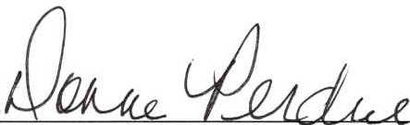

Donna Perdue, Acting City Clerk
If a person decides to appeal any decision made by the Planning Council with respect to any matter considered at the meeting, if an appeal is available, such person will need a record of the proceeding and such person may need to ensure that a verbatim record of the proceeding is made, which record includes the testimony and evidence upon which the appeal is to be made. ALL INTERESTED PERSONS DESIRJNG TO BE HEARD ON THE AFORESAID agenda are invited to be present at the meeting.
Any person requiring special accommodation at this meeting because of a disability or physical impairment should contact the City Clerk at I00 I West Park Street, Parker, Florida 32404: or by phone (850) 871-4104. If you are hearing or speech impaired and you have TDD equipment, you may contact the City Clerk using the Florida Dual Party System, which can be reached at 1-800-955-8770 (Voice) or 1-800-955-8771 (TDD).

