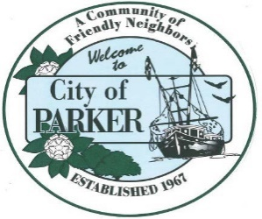 | CITY OF PARKER  AGENDA ITEM SUMMARY  MEETING DATE: 11-16-23
- ITEM: 3  PLACED ON THE AGENDA BY:  Attorney Sloan  PRESENTED BY:  Attorney Sloan |  | - PURPOSE:  PRESENTATION ____  PUBLIC HEARING ____  APPROVAL ___  REGULAR ____  DISCUSSION _x__
- IS THIS ITEM BUDGETED (IF APPLICABLE)
YES___ NO___ N/A_x_
- BACKGROUND: Mr. Sloan has asked that the committee engage in a discussion about the implications that this new information may have on the Parker Land Development Rules.
ATTACHMENTS: Chapter 2023-17
- REQUESTED MOTION/ACTION M____ 2ND____

